@ = check_box
Water differences dashboard analytics

Water differences dashboard analytics
Waste zone from a list several or all (show the table value and description)-index_waste_zone
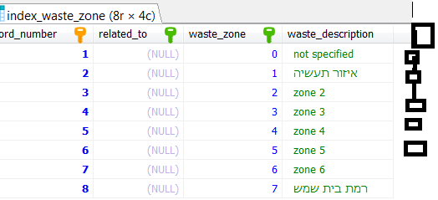
belongs_to_group: SELECT FROM A LIST several or all (make select distinct to find) –index_waste_group)
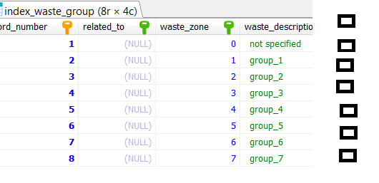

Mone_av select from list (according to former selection )
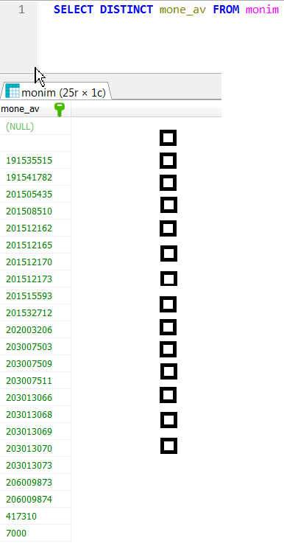

Dates : min - max
Delta min_ - max
Per cent min - _ max

X – exis : date @ ezor @ group @ mone_av@
Sum: daily @ weekly @ monthly @ yearly@
Graph : pie@ line @ bar @ area @
Y = qty @ real_qty @ ,per_cent @ delta @ all @
Graph header ____________________________________

Here graph

When graph shows:
Zoom , walk right or left
Show table of the data you used for graph , create csv, save picture

